The Basic Underlying Theory of the Plasmoid Paradigm
(Top: Plasmoid trench on aluminum from the Correas’ Labofex Technical Report 1993. Bottom: Plasmoid tunnel; and on the surface it would look like a caterpillar track from Daviau et al., Annales Fondation de Louis de Broglie, 2013 ) 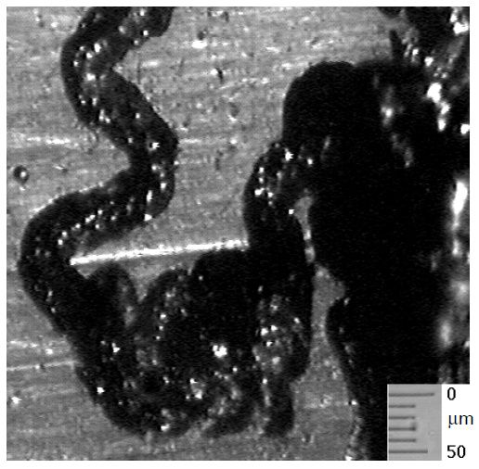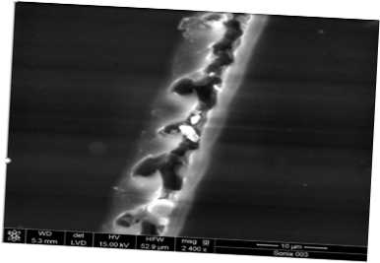

Edward Lewis, scientificrevolutions.com, onyshua@gmail.com, May 31, 2019
In 1992, while reading Matsumoto’s description of finding micrometer-sized ring markings, I realized that micrometer-sized ball lightning were being formed in transmutation and cold fusion experiments. I also came to understand that atoms could convert to be ball lightning-like plasmoids(1).
I knew from personal experience with a micro ball lightning about 2 mm wide entering deep into my wrist that matter and energy were basically the same thing. I hit a rock and out came this energy-like object that passed through my skin without damaging it (I saw it do so), and I came to believe that it maybe converted to electricity inside me because I felt a sharp pain like a shock or burn. So since then I have always basically thought that atoms can ENTIRELY convert to electricity or electromagnetic radiation and that energy can convert to atoms.
Basic Key Hypotheses
Atoms exist in states: On the earth, along with solid, liquid, gas, and plasma, the plasmoid state is the fifth natural state of matter. Atoms in a plasmoid state have their own properties.
Electricity clumps: Electricity can form tight structures called plasmoids. This fundamentally contradicts essential assumptions of quantum mechanics theory. I don’t think that atoms themselves are structured the way that QM theorists have tried to explain them in the prior paradigm. Atoms can convert entirely to electromagnetic radiation, electricity, and other energy and vice versa.
Plasmoids exist in states: We call them the black, active white, and maybe grey states. In the active white state, microplasmoids are highly reactive and effective to cause changes in the atoms around them. They can transmute atoms and also convert atoms to a plasmoid state. If they remain relatively stationary in a material, they may still transform in shape and transmute and change position. They can also fly off as flying plasmoids like micro ball lightning or macro-sized ball lightning. In a white state, white plasmoids can bore through materials while "sloshing." That is, transforming the atoms to a plasmoid state so that they move with little or no heat. In a dark state, they can pass through glass and walls, and if they are black enough, even metals without boring and leaving tunnels. They may leave no visible effects after they pass through.
Atoms in a plasmoid state may transmute to other atoms and transform to other shapes. That is, they may form geometrical patterns, geometrical structures, crystals, and move around in their shapes in or through solids or other substances. They may emit particles or various radiation including x-ray beams. They slosh, moving with little or no heat or friction at seemingly cool temperatures so that even materials with high melting points will behave like they are frictionless like a superfluid. They also have superconductive properties. Every lightning bolt and spark discharge is led by a ball lightning or plasmoid. For an example of plasmoid state atoms, Dash’s filaments in the early 1990s were in the plasmoid state.
Plasmoids are universal: Bostick showed that the galaxies have a plasmoid structure. Tornadoes are macroplasmoids. The planets, asteroids and moons are covered with plasmoid markings. Gravity and time are both plasmoid effects that can be produced.
1) E. Lewis, A Description of Phenomena According to My Theory and Experiments to Test It (1992).

